NAME:Rishik JK
REG.NO :192511052

CSA1702-ARTIFICIAL INTELLIGENCE
LAB EXPERIMENT

Experiment 12: Tic Tac Toe Game

Aim
To write a Python program to implement a Tic Tac Toe game for two players.

Algorithm
- Start the program.
- Create a 3×3 board with empty spaces.
- Assign symbols X and O to two players.
- Display the board.
- Ask the current player to enter a position from 1 to 9.
- Check whether the selected position is valid and empty
- Place the player's symbol in the selected position.
- Check whether the player has won by completing a row, column or diagonal.
- If all positions are filled without a winner, declare a draw.
- Otherwise, switch players and repeat until the game ends
- Stop the program.
OUTPUT:
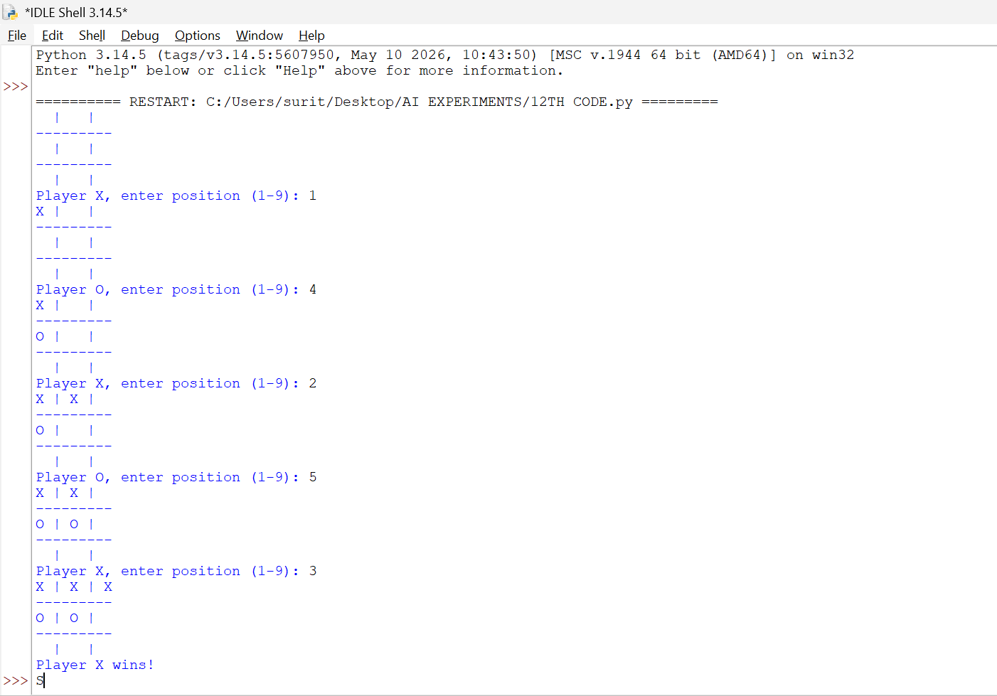

RESULT:
Thus, the Python program to implement the Tic Tac Toe game was successfully executed, and the winner was determined based on the game rules.

